**NAME: AARTI PATEL**

**STD: TYBSCIT**

**ROLL NO: 038**

**SUBJECT: DEVOPS**

**(PRACTICAL NO 1)**

**INSTALLATION OF GIT**

**SIGNATURE:**

**Steps to Install Git**

1. **Download Git:**
   * Visit <https://git-scm.com/downloads>.
   * Click on **Windows** to download the .exe file.

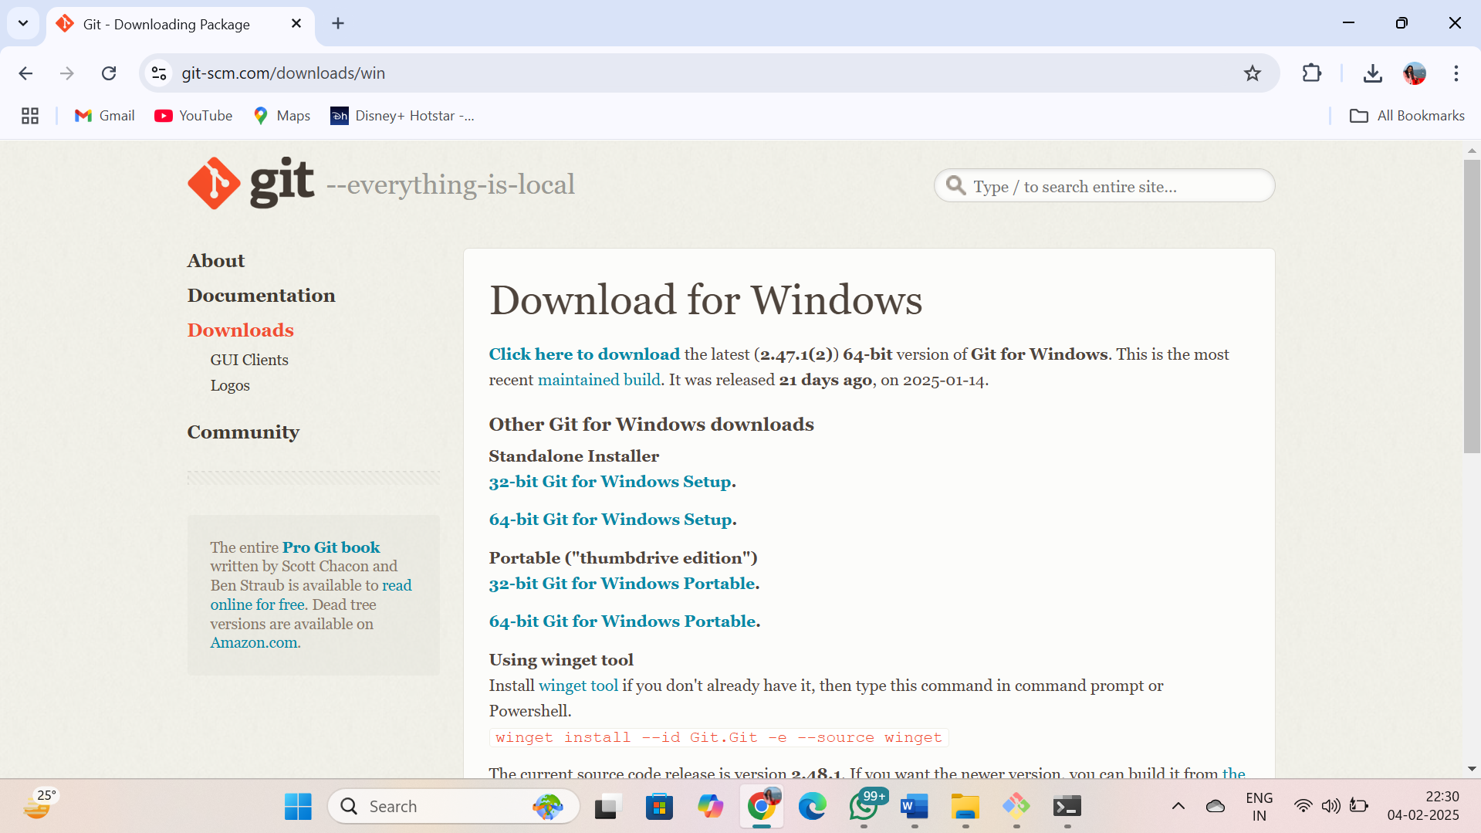

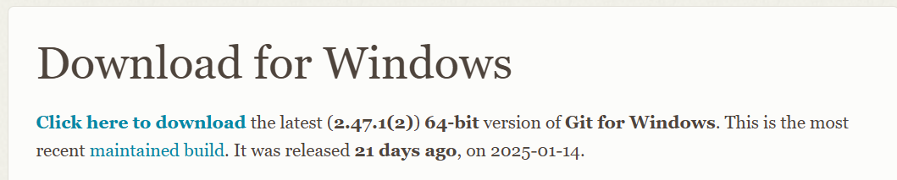

1. **Run the Installer:**
   * Double-click the downloaded file to start the installation and click on install.

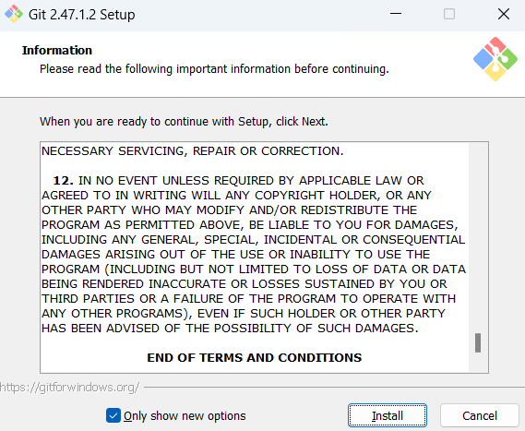

1. **Setup Wizard:**
   * Click **Next** on the setup window.
   * Select the default options unless you have specific preferences:
     + **Choose the editor:** (e.g., Vim, Notepad++).
     + **Adjust PATH environment:** Select **“Git from the command line and also from 3rd-party software.”**
2. **Configure Line Endings:**
   * Choose **“Checkout Windows-style, commit Unix-style line endings”** (recommended).
3. **Complete Installation:**
   * Click **Next** until the install button appears, then click **Install**.
   * After installation, click **Finish**.

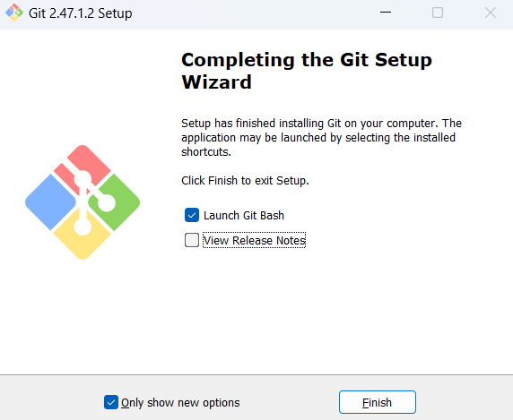

1. **Verify Installation:**
   * Open **Command Prompt** or **Git Bash**.
   * Type: git –version

